THE PRESIDENT’ OFFICE
REGIONAL ADMINISTRATION AND LOCAL GOVERNMENT
LONGIDO DISTRICT EXAMINATION SYNDICATE

HISTORY EXAMINATION
FORM FOUR PRE – MOCK EXAMINATION

SECTION A (20% MARKS)
- Total marks 15% each 01 mark)
i | ii | iii | iv | v | vi | vii | viii | ix | x | xi | xii | xiii | xiv | xv
E | D | D | D | C | D | B | C | D | FREE | A | A | D | C | B

- Total 05% (each 01 mark)
i | ii | iii | iv | v
K | E | J | B | I

SECTION B (345% marks)
- With clear examples, explanation on the following terms as used in History. (Total marks 12. (each 02% marks)
- Kinship organization
Clan was the organization, which involved combination of several related families with a common ancestor. Clan organization combined with both the matrilineal and matrilineal societies. In the patrineal societies clan heritage was based on the father, in the matrilineal clan heritage was based on the mother examples of this society were Mweras, Kambas and Kikuyus whom others are patrineals. Pan Africanism

- Pan Africanism.
Pan-Africanism this was a movement which opposed the oppressions over all the black people in the world.
Pan-Africanism had its root from America and Caribbean, it started by by black people who were in America due to Triangular Slave Trade, after the independence of American in 1776, were still segregated and humiliated because of their color. In 1900's the movement started to spread worldwide and reached its peek in 1945. The movement were organized by different elites black people.

- Neolithic revolution
Is the term for the first agricultural change describing the transition from nomadic, hunting and gathering to permanent settlement. Neolithic revolution brought socioeconomic changes such as establishment of permanent settlement, extension of division of labor based on age and sex, emergence of specialization and surplus production. This took place during last phase of stone age.

- Assimilation policy
The term assimilation means ‘similar to.’ The French used this term to refer to a system of administration that aimed at creating French Black Africans amongst the West Africans who would be French citizens. The French wanted the French Black Africans to enjoy the same status and privileges or suffer penalties like any French citizen in France.

- Chimurenga
This was the resistance between two tribes, Shona and Ndebele against the British rule in Zimbabwe in 1896-1897 under the leadership of King Lobengula. Therefore Chimulenga war was the traditional resistance which was organized by Shona and Ndebele tribe against British rule in Zimbabwe Chartered company

- Charted company
These were the administrative companies appointed by the colonial powers (nations) to administer the colonies in Africa on behalf of their mother government (metropolitan government). It was after the Berlin Conference of 1884-1885. During this time European countries used trading companies to colonize Africa on behalf of their mother country. Example in Nigeria; British used the Royal Niger Company, in Rhodesia the British South Africa Company used, also in East Africa the imperial British East Africa Company used and German East Africa Company.

- Total marks 12% each 02% marks
i | ii | iii | iv | v | vi
2 | 5 | 1 | 4 | 3 | 6

- Map question total marks 11%. (Locating each 02% and map 01%)

THE MAP OF AFRICA SHOWING AFRICAN COLONIES
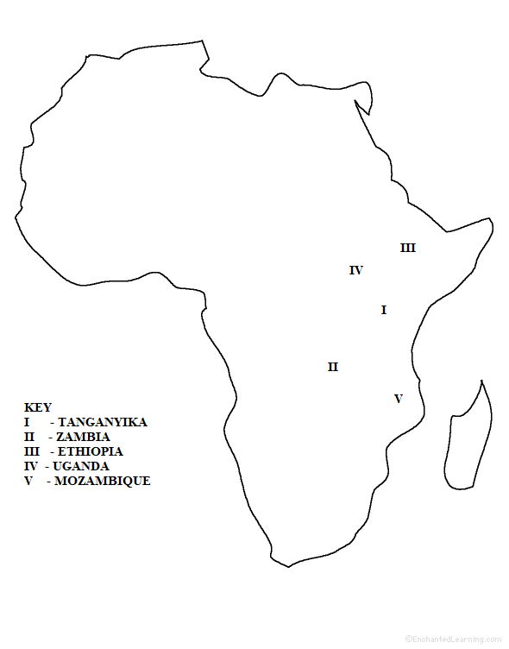

SECTION C
Total Marks 45% Student should answer any three questions (Each Question 15%)

NOTE: Introduction 1.5%
Main body 12% (each point 02% marks)
Conclusion 1.5%
- Describe six (6) mechanisms of Neo – colonialism to the third world countries.

INTRODUCTION
Meaning of Neo colonialism
Period – after independence of African states from 1960
Examples of colonial masters (ex colonial master)

MAIN BODY
Mechanism of Neo colonialism in third world countries
- Through control of world market
- Through Mass investment by imperialist
- Through loans and grant
- Through policies making.
- Through technology
- Through provision of loans.
- Through depending experts
- Through mass media. /propaganda
- Through scholarship or western education
- Through provision of aids.
- Through establishment or military base.
CONCLUSION
Student should give any relevant information like impacts of neo – colonialism in third world countries.

- Despite of presence of different ways of obtaining historical information. Oral tradition has remained to be the best method. How far is this statement true? Give six points.

INTRODUCTION
Meaning of oral tradition
Types of oral tradition
Other way of obtaining historical information

MAIN BODY
Importance of oral tradition
- It preserve and reveal historical information which are not recorded (it preserves information)
- Both illiterate and literate people can obtain historical information. (it can be used to both illiterate and literate people)
- Within oral tradition, there are warning and teachings. (it contains teachings and warnings)
- Is the easiest and cheapest method of obtaining information?
- It is live source, since it involves physical interaction.
- It is a source of entertainment

CONCLUSION
Student should give any relevant information like the weakness of oral tradition.

- “FRELIMO, PALGC, MPLA and UNITA were political parties formed for attaining independence in the former Portuguese colonies in Africa.” Explain why the government in the Portuguese colonies engaged in guerilla warfare (Six points only).

INTRODUCTION
Meaning of guerilla warfare (armed struggle)
Period of attaining independence 1975
Examples of Portuguese colonies in Africa (Angola, Mozambique etc)

MAIN BODY
Student should discuss the factors for armed struggle in Portuguese colonies
- Heavy investments
- Banning of political parties
- Imprisonment of political leaders
- Lack of democracy
- Presence of many settlers
- Intensive colonial exploitation
- Racial segregation

CONCLUSION
Student should give any relevant information like factors for the success in political independence in Portuguese colonies.

- First World War has remained to be the historical phenomena. With clear example examine 6 motives why this phenomena was inevitable?
INTRODUCTION
Meaning of WW1
Period of WW1 1914 – 1918
Participants Triple Alliance against Triple Entente.

MAIN BODY.
Student should discusses the causes of WW1
- The development of capitalism into the highest stage in 1860’s
- Dissatisfaction in territorial division
- The rise of military alliances
- The France desire to regain Alsace and Loraine
- The Balkan crisis (Balkan nationalism):
- Moroccan Crisis 1905 and 1911
- Arms race and militarism
- The assassination of Archduke Franz Ferdinand and his wife

CONCLUSION
Student should explain any relevant information like the impacts of WW1 in the world.

